PROPERTIES OF METALS AND NON-METALS

Metals

• Capable of being highly polished (they have a lustre or are shiny when cut).
• Good conductors of heat and electricity.
• All are solid at room temperature (except for mercury).
• Can be hammered into thin sheets (malleable) and
stretched into wires (ductile).
• Found on the left-hand side of the Periodic Table.
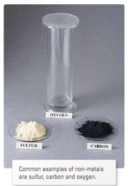

Non-metals

• Usually don't shine when polished.
• Poor conductors of electricity (except carbon), and heat.
• Exist as solids, liquids and gases at room temperature.
• Those that are solid are brittle (they shatter).
• Found on the right-hand side of the Periodic Table.

Metalloids

• Have properties of both metals and non-metals.
• Only 8 elements belong to this group.
• Found between the metals and non-metals towards the right-hand side of the Periodic Table.

